APEM System Requirement Study

1. Sales Order Entry

.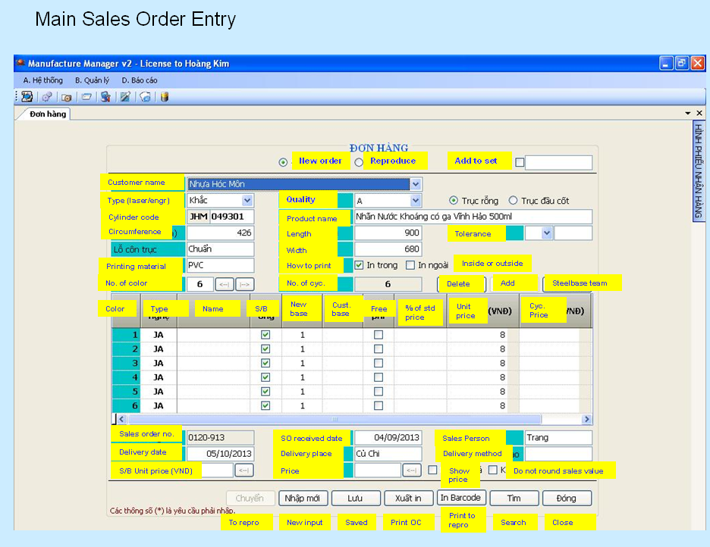

Main Interface:

1. Option for “JOB TYPE” → 1. DLS (L) 2. EMG (M) 3.LASER ETCHING (E) 4.EMBOSSING (S) 5. OTHERS (X) (This is to cater auxiliary order)

2. Additional field:
2.1. Design Name column
2.2. Remark/Note column
2.3. Customer PO number

3. Purchase Order option to steelbase supplier for new steelbase purchase. New entry screen needed.

4. Existing root job no. for reference

Cylinder Details Table:

No | Field Name | Format | Description | Remark
1 | Cylinder ID/Product ID | 10 Character (Alphanumeric) | Customer  Cylinder ID | Appear in DO and Invoice.
2 | Multiple currency | USD/SG/EURO/ETC | Currency | New table- User can input daily rate
3 | Pricing (LW/CT) |  | Per cm square | LW – Old base / LW – New base  CT – Old base / CT – New base
4 | GST Tax Code
5 | GST Tax Percentage
6 | Pivot cylinder
7

2. Auxiliary Order Entry Screen– Not needed. All auxiliary orders will be keyed-in into main sales order entry screen.

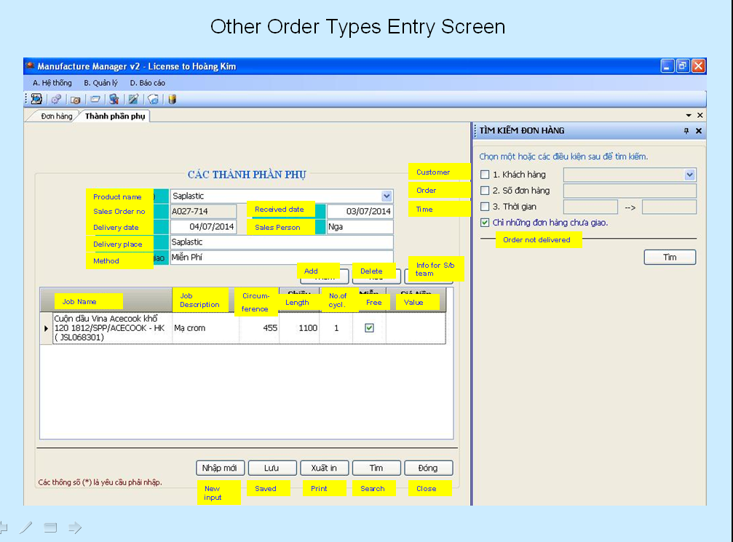

Main Interface:
- Customer Name
- Customer ID
- Customer PO/reference no:

Job Details table:

No | Field Name | Format | Description | Remark
1 | Work Order No | xx Char |  | Appear in DO and Invoice
2 | Product ID | xx Char |  | Appear in DO and Invoice
3 | Multiple currency
4
5

3. Repro Input Screen

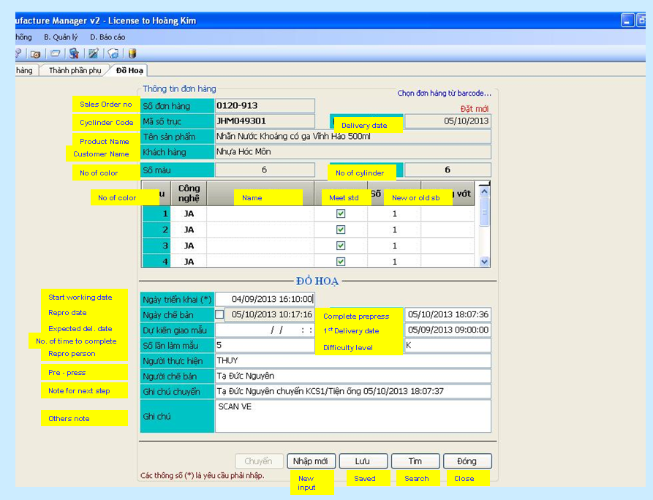

3.1 Eye Mark

No | Field Name | Format | Description | Remark
1 | Size | 5 x 10 mm | mm | Important
2 | Colour | 10 char |  | Important
3 | Backing | 20 char |  | Optional
4 | Eyemark position | Picture | Image direction | Optional
5

3.2 Unit size and Barcode of product:

No | Field Name | Format | Description | Remark
1 | Size % | 3 char |  | Important
2 | Colour | 10 char |  | Important
3 | No | 15 char |  | Important
4 | Supply | 10 characters | Status | Optional
5 | Unit size | V: 000.00 x H:000.00 |  | Important
6 | BWR | 0.00 |  | Optional
7 | Printing Direction |  |  | Optional
8 | Traps Size |  |  | Optional
9 | Opaque Ink |  |  | Optional
10 | Endless |  |  | Optional
11 | Colour Target |  |  | Optional

3.3 Layout images of cylinder: (S & R)

No | Field Name | Format | Description | Remark
1 | No. of repeats | H: yy x V: zz |  | Important.
2 | Autotrons: | 5 char |  | Optional
3 | Cutting Marks: |  | Yes or No | Optional
4 | Up-Numbering: |  | Yes or No | Optional
6 | Info engraved on Cylinder | 50 Characters |  | Optional

4. ENGRAVING PROTOCOL

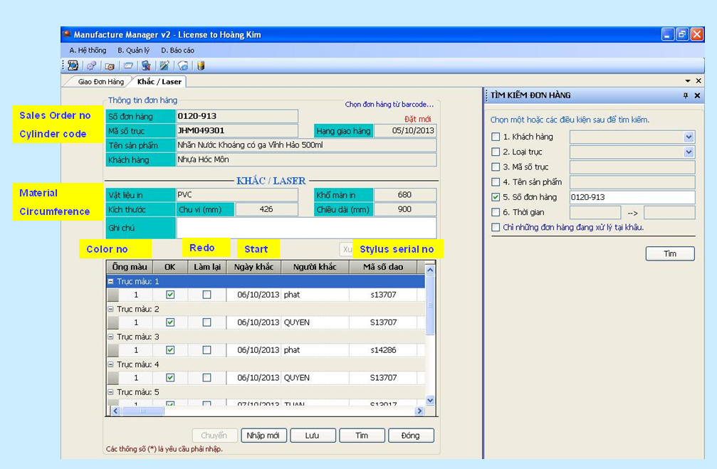

4.1. Mechanical Engraving - sample

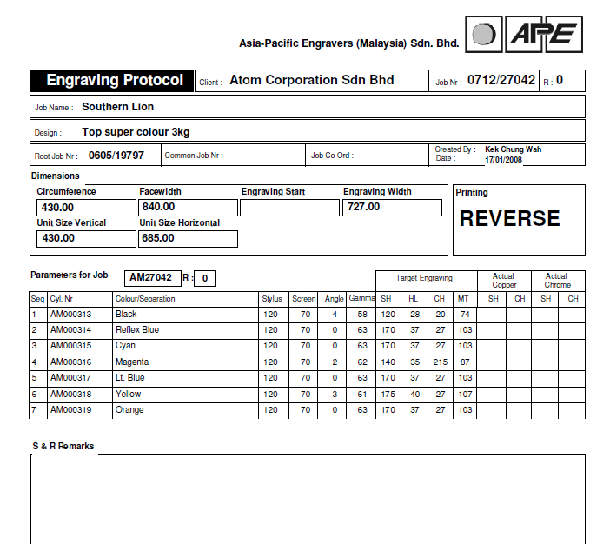

  - Laser Engraving - sample

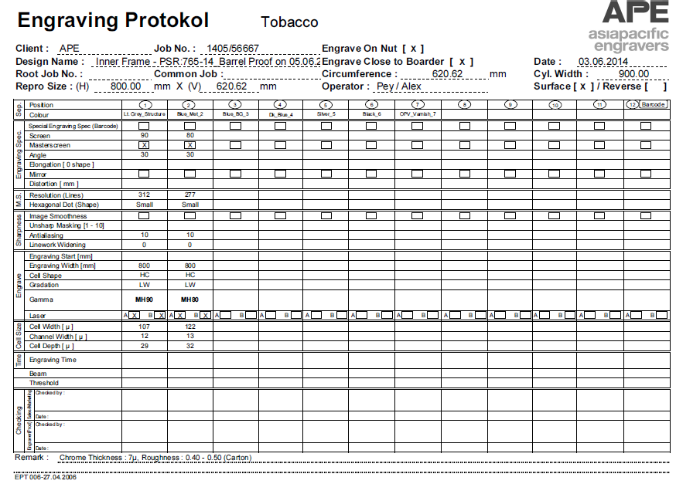

  - Laser Embossing Protocol – sample -- bỏ

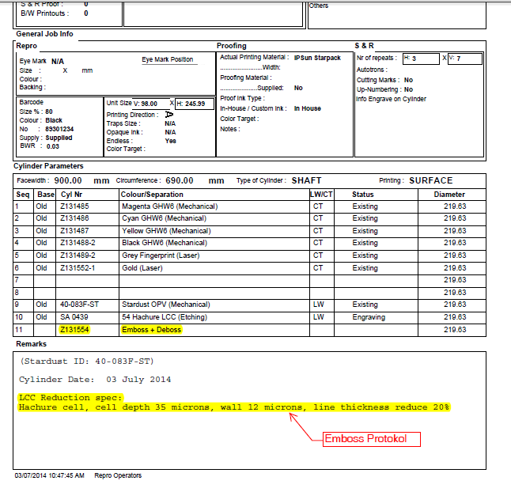
4.4 Laser Etching Protocol - sample

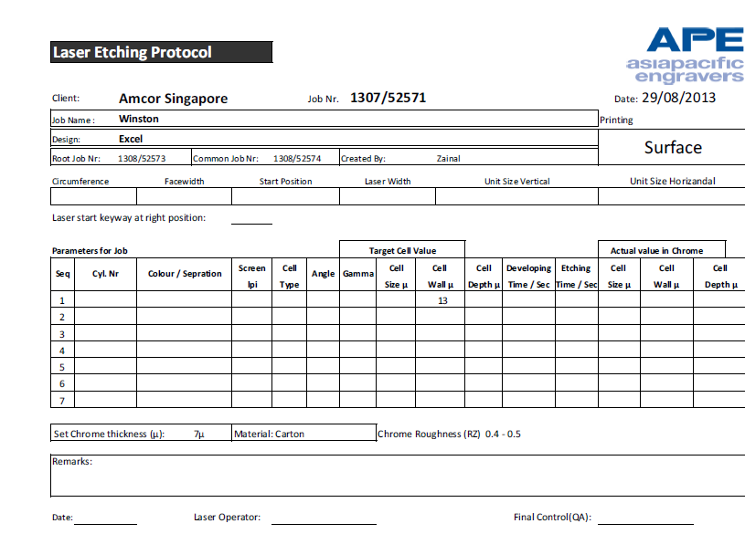

5. Production Process Flow

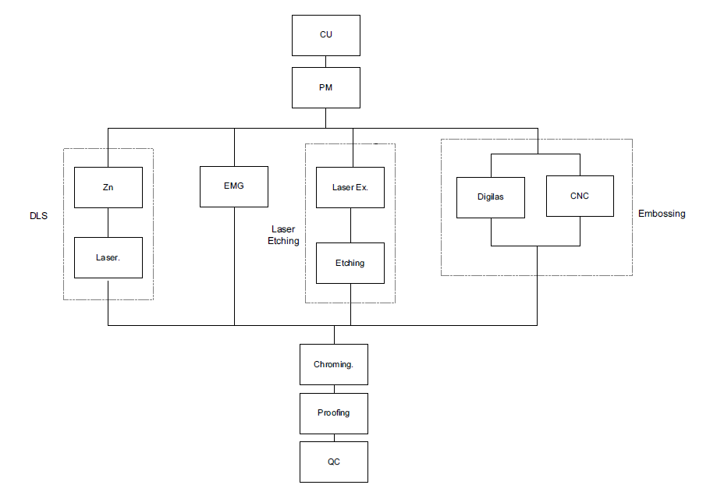

Note:

- To capture start time and end time for each processes. Not tied to employee ID.

  - CU

  - PM

  - DLS
    - ZN
    - LS

  - EMG

  - Laser Etching

  - Embossing
    - Digilas
    - CNC

  - Chroming

  - Proofing

  - QC

- Report and Forms

6.1. Cylinder certificate - sample

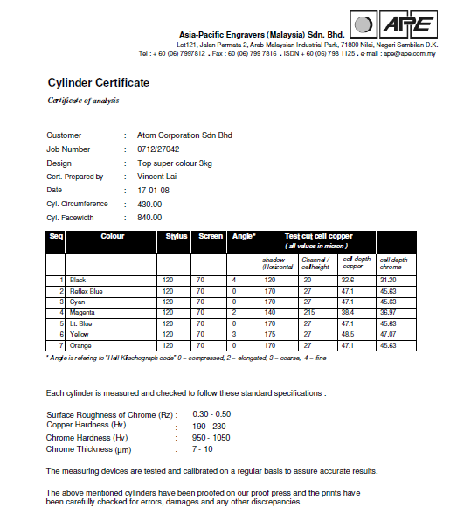

  - Delivery Note – For transporter

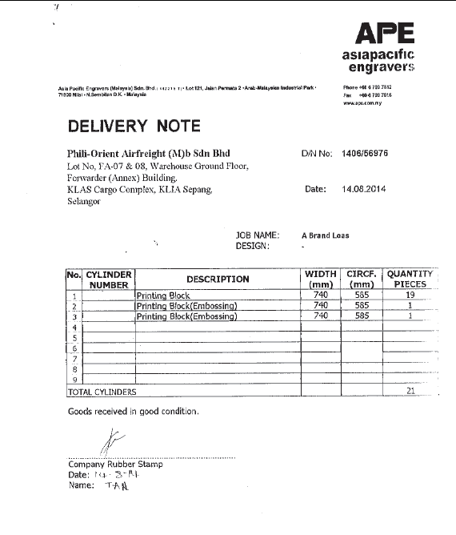

  - Delivery Order - sample

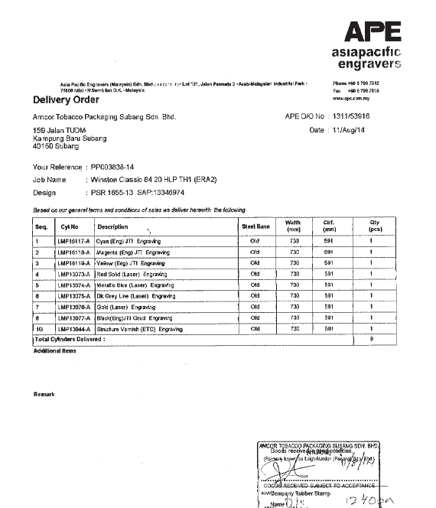

  - Invoice – sample 1 (Mechanical)

  - Invoice – sample 2 (Laser/Tobacco)

  - Invoice – sample 3 ( Auxiliary Order→Engraving/”De/recrome job”/ etc)

  - Invoice – sample 4 (Artwork job - Philip Morris)

Note:

- Need to standardize the invoice format based on main input screen.
- To include GST information (APE GST Company Code, GST Tax code and Percentage)
- Multiple currency option
- Customer PO Number.

  - New Steelbase PO

    - To include purchase price.
    - PO running no. format.
    - Receiving procedure.

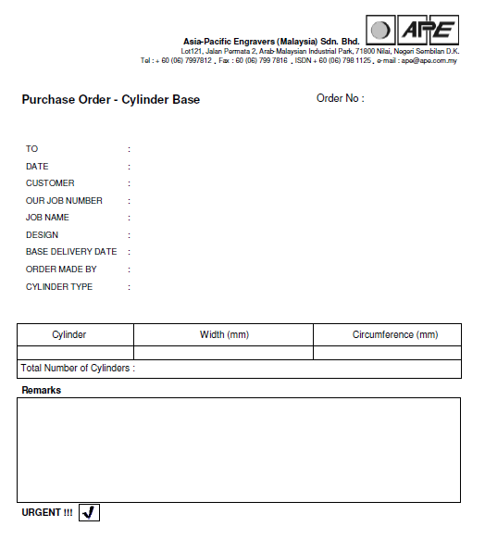

Report:

Sales:

- Sales report by weekly, monthly, yearly
- Sales report by customer
- Sales report by sales representative
- Sales report – incoming order

Production.

- Production schedule – Job in progress
  - repro status
  - engraving status
  - de/rechrome status
  - Cylinder/steelbase readiness status

- Production schedule – Engraving date not assigned
- Production schedule – de/rechrome date not assigned
- Production schedule – remake order.
  - Internal reject - qty
  - External reject - qty
  - Revision details (e.g. stylus break/chrome peel/wrong barcode size/etc)

7. Issue

- Printout of job sheet
  - Need to manually key-in the job details on job sheet → Customization required to have an automatic job details on the printout
  - To define the layout of job sheet.
  - APEVN – Job sheet without repro details. For APEM, we need to define the process flow for job sheet creation.

- To incorporate engraving protocols into the system or to have it on separate file (excel format). This will depend on complexities of customization required.

- Sales invoice information to be downloaded to excel template. The excel template should be able to be recognized by SAP during uploading process for GST capturing purpose.

